Task 6 :
Understanding Projects, Boards, Statuses and Workflows - 1 hour(s)
- Customizing Your Jira Board View Without Admin Access
- Workflow States and Transitions: What You Can See and Do
Working Smart: Cross-Team Collaboration and Long-Term Projects - 2 hour(s)
- Managing Cross-Team Work in Jira
- Creating and Using Shared Boards for Team Collaboration
- Roadmaps in Jira: Visualizing Plans and Dependencies

Understanding Projects, Boards, Statuses and Workflows
Customizing Your Jira Board View Without Admin Access
Different people needs different perspectives, one workflow may have many perspectives, no permission dependency.
Board customization = Personal productivity
Admin controls workflows but boards map workflow statuses into columns

Workflow States and Transitions: What You Can See and Do ::
In Jira, a workflow shows how an issue moves from start to finish.
Workflow states are the different stages of work, such as To Do, In Progress, and Done. You can see the current state of an issue on the board or inside the issue details.
Transitions are the actions used to move an issue from one state to another, like starting work or marking it as complete. You can change an issue’s state by dragging it on the board or selecting a transition button inside the issue.
In a board if button is enabled then tranisition is allowed and if not visible or enabled then the transition is not allowed. IT may be due to role based restrictions, required fields.

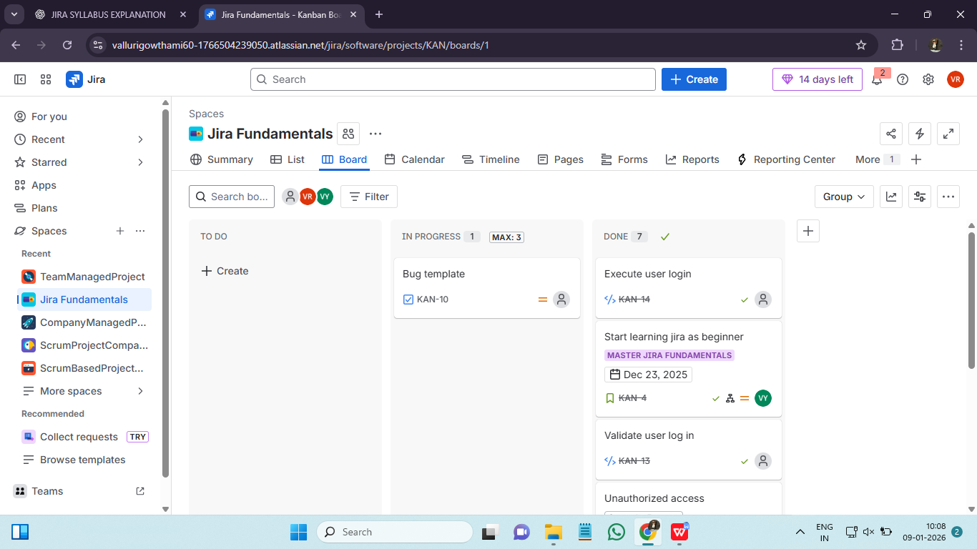

Working Smart: Cross-Team Collaboration and Long-Term Projects ::
Managing Cross-Team Work in Jira ::
Cross team work happens when more than one team works on same goal over longer duration. Managing cross-team work in Jira means coordinating tasks that involve multiple teams working together on the same project or related projects.
Teams can use linked issues to show dependencies between tasks handled by different teams. Epics help group related work across teams, while shared boards and filters allow everyone to track progress in one place. Assigning clear owners and using comments improves communication.
Using Jira in this way helps teams stay aligned, track dependencies, and complete work smoothly across teams.

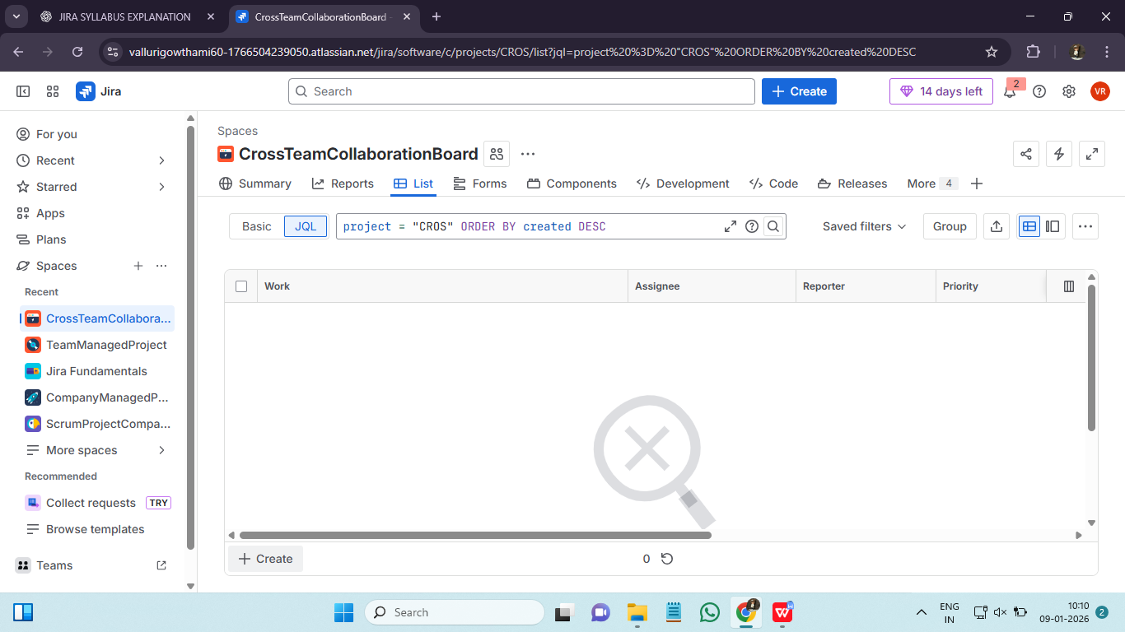

Creating and Using Shared Boards for Team Collaboration ::
Shared boards in Jira help teams work together by showing issues in a common view.
To create a shared board, a board is set up using a saved filter that includes issues for all team members. The board is then shared with the team so everyone can view and use it. Team members can track progress, update issues, and move tasks across workflow stages.
We can use shared boards in following scenarios :
- Multiple teams work on same epic
- Dependencies exists between teams
- We run scrum of scrums
- Long term intiative span teams
A shared board is built using :
- One / more projects
- A board filter
- Swimlanes
- Quickfilters
- Permissions

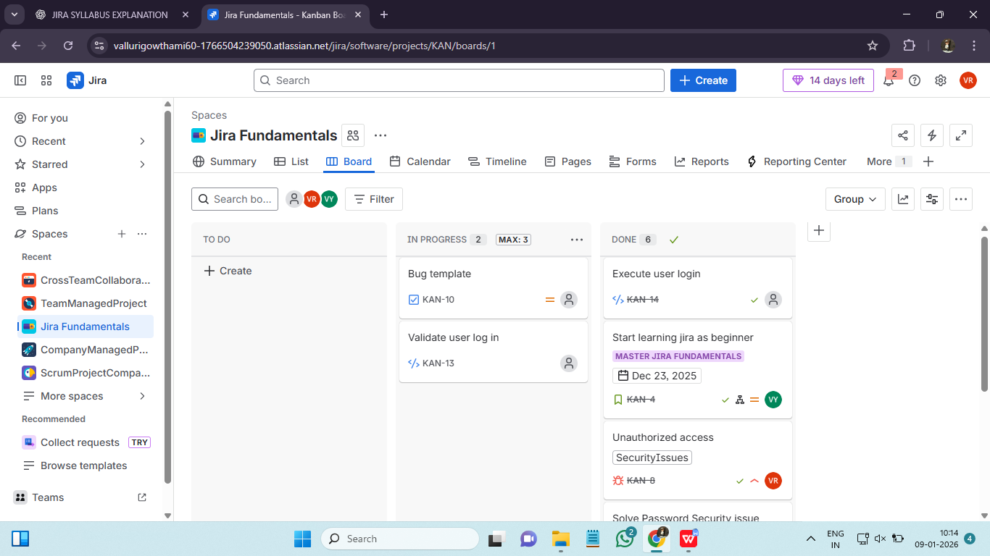

Roadmaps in Jira: Visualizing Plans and Dependencies ::
Roadmaps in Jira provide a visual timeline of work, helping teams plan and track progress over time.
They show Epics, issues, start and end dates, and how work is connected. Roadmaps help teams understand dependencies, plan releases, and see how changes affect timelines. Users can adjust dates, track progress, and identify risks early. These are strategic and long term planning.
Using roadmaps makes planning clearer and helps teams stay aligned on goals and deadlines.
If overlapping boards : parallel work
Dependency lines : risk points
Date conflicts : schedule issues 